USE CASE DIAGRAM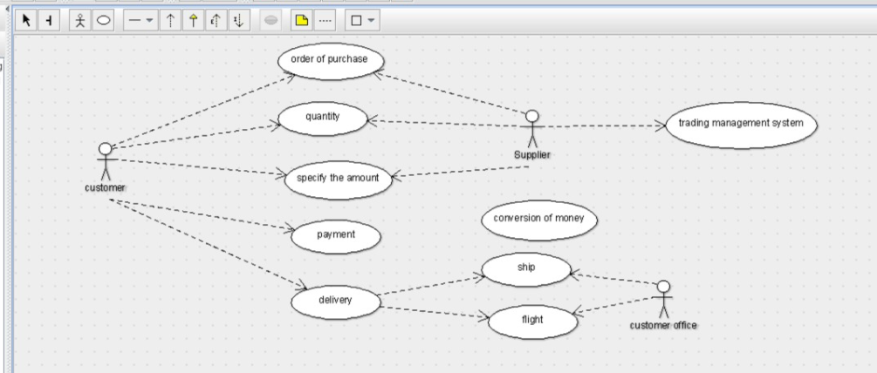

CLASS DIAGRAM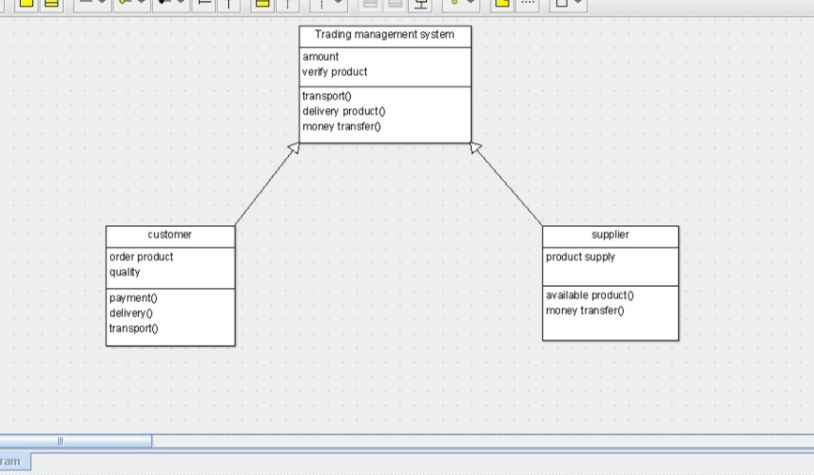

public class customer extends Trading management system {

public order product;

public quality;

public void payment() {

}

public void delivery() {

}

public void transport() {

}

}public class Trading management system {

private amount;

public verify product;

public void transport() {

}

private void delivery product() {

}

public void money transfer() {

}

}public class supplier extends Trading management system {

public product supply;

private void available product() {

}

public void money transfer() {

}

}

SEQUENCE DIAGRAM

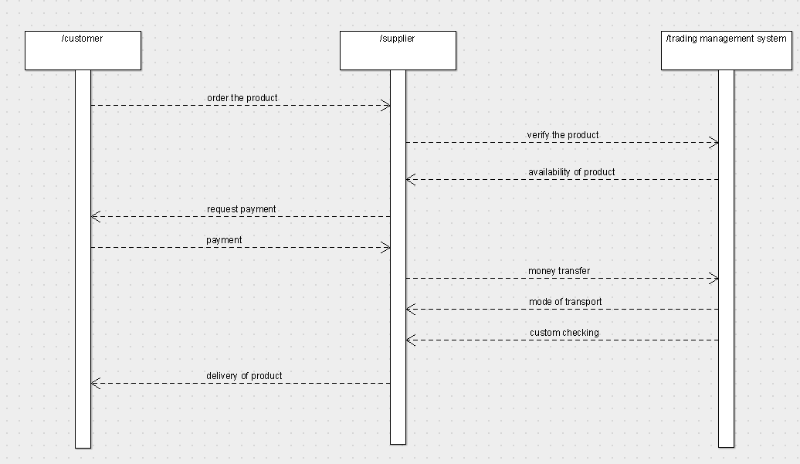

COLLABORATION DIAGRAM

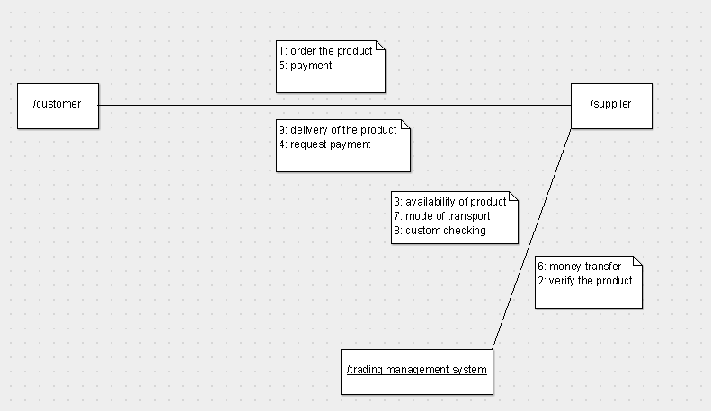

ACTIVITY DIAGRAM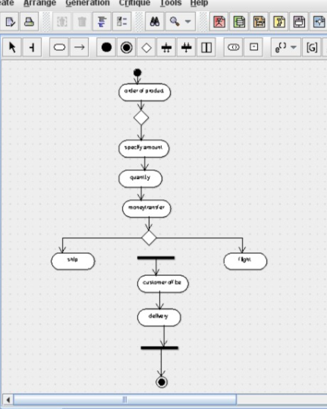

STATE DIAGRAM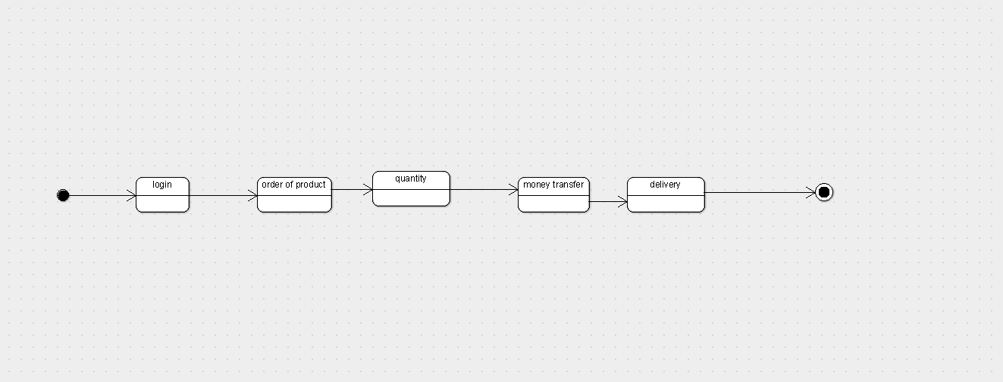

COMPONENT DIAGRAM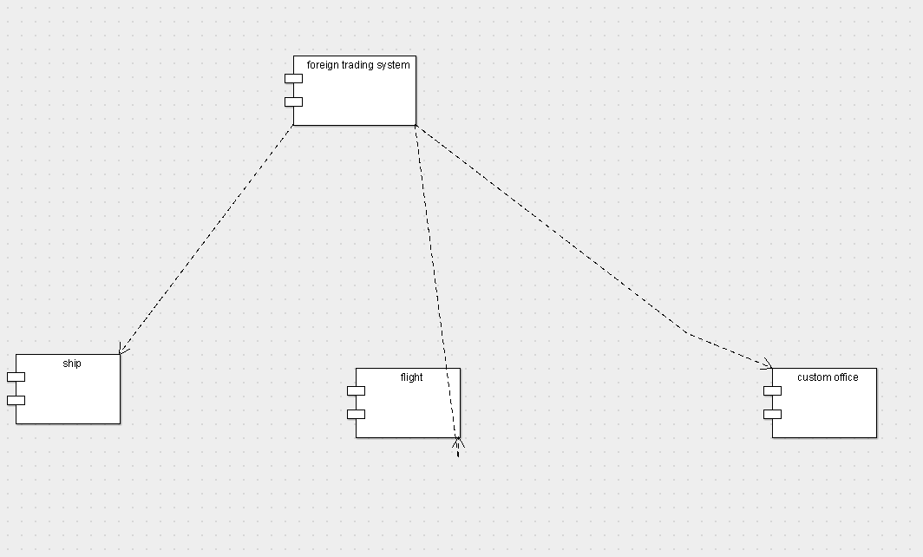

DEPLOYMENT DIAGRAM